Assignment IP

For each of the source code fragments below 1) compute the cyclomatic number 2) construct a set of independent paths through the source code fragment with a path predicate for each independent path. Use line numbers to describe the independent paths and use Boolean conditions from the source code to describe the path predicates. Example of response format is shown below.

Example
V(G) = 3  ------------------------------  1 if (a<10) //C1  2 x++;  3 else if (b>15) //C2  4 y++;  5 z++; | Legend: T = true, F = false, X = irrelevant
  Path # | Path | a<10 | b>15
  1 | 1-2-5 | T | X
  2 | 1-3-5 | F | F
  3 | 1-3-4-5 | F | T

(Problem 1) | (Problem 2)
1 void P1 ( ) {  2 S0 ;  3 if (C1) {  4 S1 ;  5 for (int i=0; C2; i++) {  6 if (C3) {  7 S2 ;  8 }  9 else {  10 S3 ;  11 }  12 }  13 S4 ;  14 }  15 else {  16 S5 ;  17 }  18 } | 1 void P2 ( ) {  2 S0 ;  3 if (C1) {  4 S1;  5 for (int i=0; C2; i++) {  6 S2 ;  7 }  8 S3 ;  9 }  10 else {  11 if (C3) {  12 S4 ;  13 }  14 S5 ;  15 }  16 S6 ;  17 }
(Problem 3) |  | (Problem 4)
1 void P3 ( ) {  2 S0 ;  3 if (C1) {  4 S1 ;  5 S2 ;  6 for (int i=0; C2; i++) {  7 while (C3) {  8 S3 ;  9 for (int i=0; C4; j++) {  10 S4 ;  11 }  12 }  13 S5 ;  14 }  15 }  16 else {  17 if (C5) {  18 S6 ;  19 }  20 else {  21 S7 ;  22 }  23 S8 ;  24 }  25 } |  | 1 void P4 ( ) {  2 S0 ;  3 if (C1 || C2) {  4 S1 ;  5 S2 ;  6 while (C3) {  7 S3 ;  8 if (C4&& C5 && C6) {  9 S4 ;  10 }  11 else {  12 S5 ;  13 }  14 }  15 }  16 else {  17 for (int i=0; C7; i++) {  18 S6 ;  19 }  20 S7 ;  21 }  22 S8 ;  23 }

Problem 1:

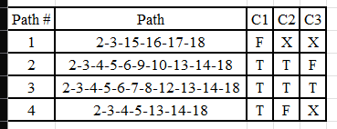

Problem 2:

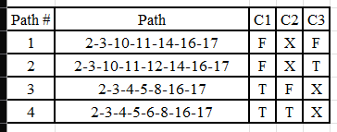

Problem 3:

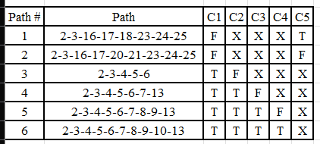

Problem 4:

